 | Autumn 1 |  | Autumn 2 | Spring 1 | Spring 2 |  | Summer 1 |  |  | Summer 2
Topic  These themes are starting points and will be adapted at various points to allow for children’s interests to flow through the provision.  English  Our medium-term plan has more detailed information. | Celebrate me. |  | Seasons and Celebrations | We are all Heroes! | Around the World |  | Outdoor Explorers
 | 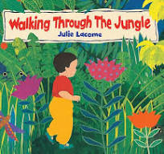  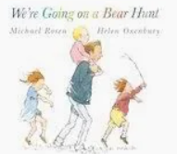  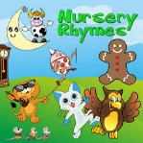  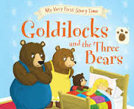  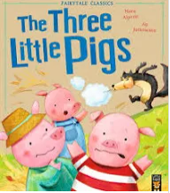  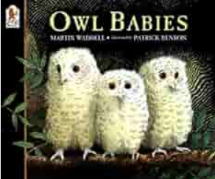 |  | 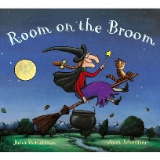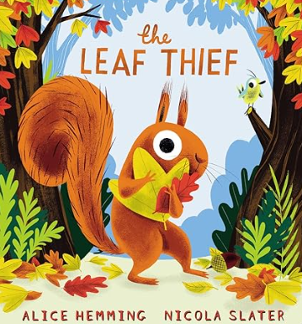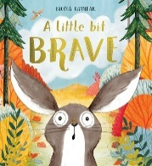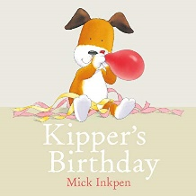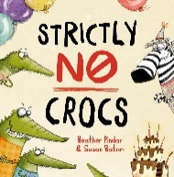 | 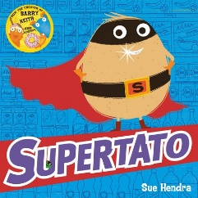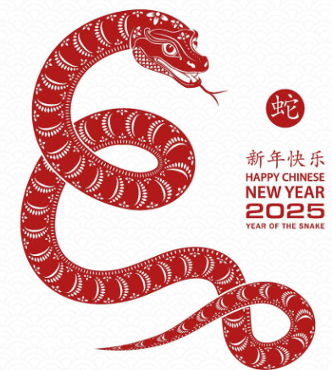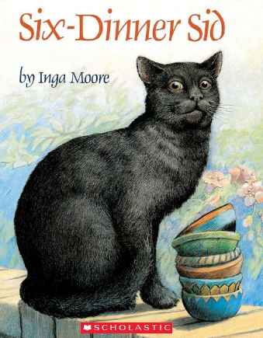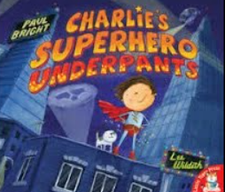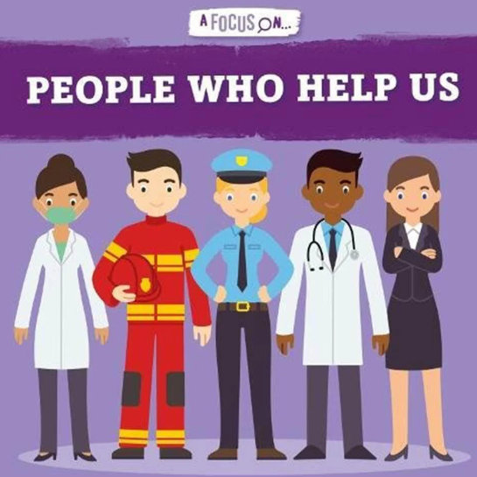 | 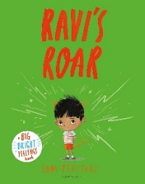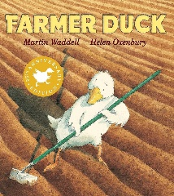  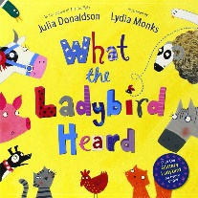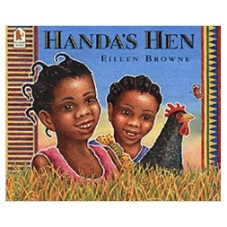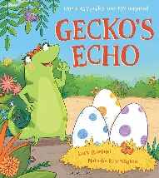 |  |  | 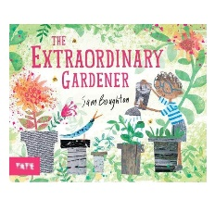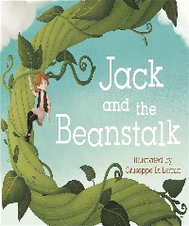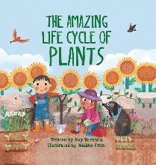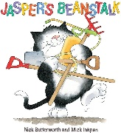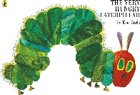 |  | 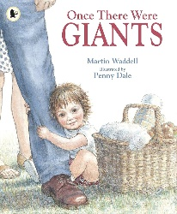  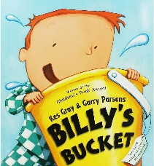  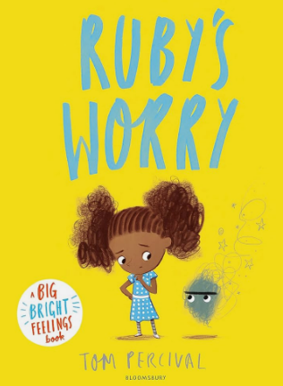  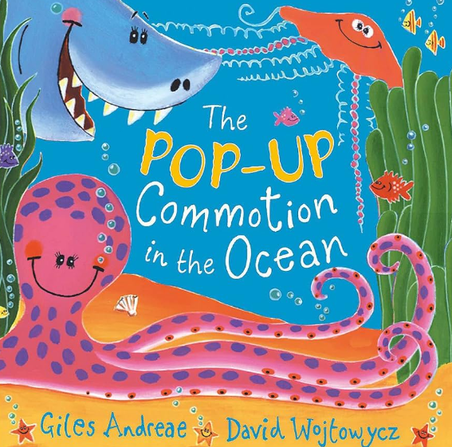  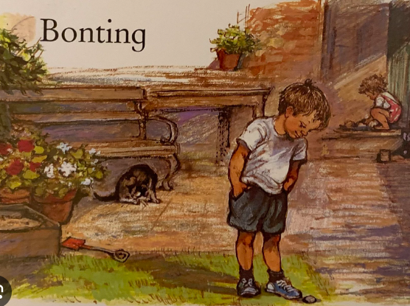
Communication and Language | A whole EYFS focus – C&L is developed throughout the year through our carefully curated enabling environments, high quality interactions, daily group discussions, planning, Helicopter Stories, PSHE lessons, daily story time, singing, speech and language intervention, EYFS productions, assemblies and targeted interventions.
Comprehension | We like to listen to stories and join in with parts that we know. |  |  | We can talk about a story after we have listened carefully.  We can answer questions about the story.  We can find books that we like. |  |  |  | We use stories we have heard in our play, acting out characters in role.  We confidently answer questions about books.  We choose to read fiction, non-fiction and poetry and can talk about why we like them.
Reading | We clap syllables for names and common words.  We can spot words that begin with the same initial sounds.  We hear rhymes.  We can read our own name.  We join in with phonics lessons and learn the sounds we are taught.  We can use the sounds we have learnt to read words. |  |  | We can read words that match our phonic ability group.  We can use our phonic knowledge to read words independently.  We can listen to our partner read to us and talk about what they have read.  We can read some tricky words (that can not be sounded out). |  |  |  | We can read words using at least 10 “Special Friends” independently.  We can read stories that match our phonic ability group.  We can talk about what we have read.  We re-read stories to build up our confidence, speed and fluency.
Writing | We use letter shapes in our writing and copy shapes and drawings.  We form lowercase letters that we have been taught correctly. |  |  | We can write our own name clearly.  We hold a pencil correctly.  We write letters with correct formation.  We can write words using our phonic knowledge.  We can read most of what we have written. |  |  |  | We can write phrases and simple sentences using our phonic knowledge.  We can plan what to write and then write it.  We can read what we have written.  We can form lowercase letters correctly.  We can write simple dictated sentences.
Maths | Our medium-term plans have more information and we use NCETM Mastering Number.
Knowledge and Understanding of the World | We can talk about our families, including using photos to remind us of events.  We can move around the school with increasing familiarity and confidence.  We play outside and explore the outdoor environment. We can talk about where we live. |  |  | We find out about people who help us,  We talk about things that have happened in the past and plan things that will happen in the future.  We look at animals, learning about babies and adult names and visit a farm for hands on experiences. |  |  |  | We learn about life cycles, with butterflies, frogs and ourselves.  We learn about plants, growing from seeds and bulbs, exploring things we grow to eat.  We investigate mini-beasts, going on bug hunts and making bug hotels.  We consider how we have changed since we started school and what will happen as we transition into Year 1.
PSED | We build relationships with our classmates and adults in our learning environment. We discuss ourselves, our interests and our feelings. | We celebrate our differences and discuss how we can help others in our lives. We discuss how our families are unique. We recognise the importance of being sensitive to our friends and learn how to solve problems. |  | We talk about how to keep ourselves safe, what we should and shouldn’t put in our mouths. We look at the clothes we wear to keep us safe and how we keep safe in our home. We start to explore how to keep safe online. |  | We discuss how our behaviour can make a difference to our families at home and to our friends at school. We explore how we care for our school grounds and the local environment. We discuss money, why we need it and how to keep money safe. | We discuss the importance of giving new things a go and how to be resilient when giving new things a go. We explore how to keep healthy when choosing food to eat. We discuss the need for sleep and exercise. |  | We talk about changes in lifecycles for creatures and humans and relate these to our own lives. We think about the changes that have happened in our school and look forward to the changes that are going to happen.
Expressive Arts and Design | We are interested in the art and construction areas, using a range of resources and using tools with care.  We play happily in the role play, engaging in imaginative play with friends.  We listen to music and say what we like and don’t like and we join in with singing. |  |  | We develop our use of a range of artistic materials, exploring colour and shape with printing and painting.  We gain skill with scissors, glue and string, combining materials to make models, little books and masks linked to books and our own ideas and interests. |  |  | We refine our skills with tools such as scissors and dough tools, creating with purpose and intent.  We use a range of materials to create props for storytelling and use them in our play.  We mix colours with paint and use them to create art that we take pride in.
RE | All About Me |  | Jesus’ Birth | Eggs as a sign of new life. |  |  | Janmashtami (Krishna’s birthday)
Physical Education | How to move as a class. Group games. |  | Body Management | Dance | Gymnastics. |  | Games - Manipulation and Control |  |  | Games - Speed, Agility, Travel
Music  Following Hampshire Music Pathways | Getting to know you  How to use instruments |  | Christmas  Learning songs | Tell me a Tale  Music for effect | Incy Wincy  Pitch |  | Rainbow Fish  Instruments can make different sounds |  |  | On the Beach  We can make our own music.
Trips, Events and Themed Days | Nursery Rhyme Dress Up Day  First Stay and Play with parents. |  | Nativity Play | Superhero Dress Up Day  Hero Themed Stay and Play  Chinese New Year Celebrations | Trip to the Gordon Brown Centre  1st April 2025  Spring Themed Stay and Play |  | Trip to Wellington Country Park  17th June 2025  Farm Themed Stay and Play |  |  | End of Year Celebrations with parents.
We appreciate and understand the importance of the outdoor environment for our children. It continues our indoor provision with intended larger scale experiences at every opportunity.

