 | Autumn 1 | Autumn 2 | Spring 1 | Spring 2 |  | Summer 1 |  | Summer 2
Topic | Continents and Oceans  (Geography) | Nightingale, Seacole, Cavell  (History) | Let’s go on an adventure! (Geography) | Plants  (Science) |  | History of Flight  (History) |  | Nepal  (Geography)
English  Please see the unit overviews for more detailed information. | 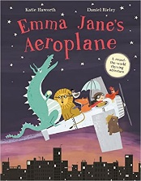 | 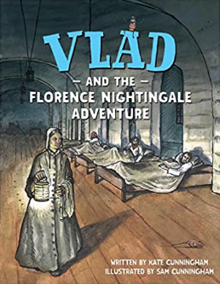    Newspaper report | 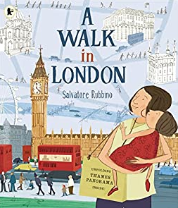 | 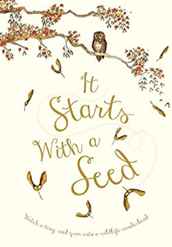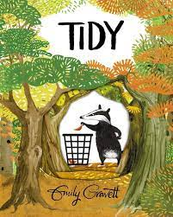 |  |  | 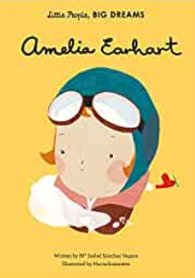 | 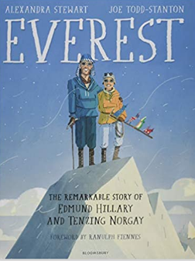
Writing Outcomes from entire unit | Outcome: To write about a day in the life of a character.  Purpose: To record events, thoughts and feelings – entertain.  Audience: A reader interested in travelling.  Form: Narrative recount  Outcome: To write a travel Guide  Purpose: inform  Audience: A reader interested in travelling.  Form: Information Leaflet | Outcome: To write a letter home as Vlad.  Purpose: entertain and inform  Audience: Vlad’s family  Form: Recount letter  Outcome: To write a comparison on Florence nightingale and Kylie Watson  Purpose: inform  Audience: Readers interested in historical texts.  Form: Information Comparison text | Outcome: To write their own story of a ‘Walk in Aldershot’  Purpose: entertain  Audience: Tourists or people new to the area/To help the local councillor  Form: Narrative/Recount  Outcome: To write a non- chronological report of Aldershot  Purpose: inform  Audience: Tourists or people new to the area.  Form: Information Leaflet. |  | Outcome: To write a poem linked to growth and change  Purpose: entertain  Audience: readers interested in poetry/ plants.  Form: poetry  Outcome: Create an interview with Pete.  Purpose: inform  Audience: Class Book  Form: Information | Outcome: To write a 1st person diary- of when Amelia flies out  Purpose: Inform  Audience:  Form: Recount  Outcome: Write a story opening  Purpose: an entertaining descriptive text  Audience: People who love reading fantasy  Form: Narrative |  | Outcome: To create an advisory text- on what to take with you.  Purpose: inform  Audience:  Form: Survival Guide  Outcome: To descriptive text  Purpose: entertain  Audience:  Form: Narrative
Reading Journey | 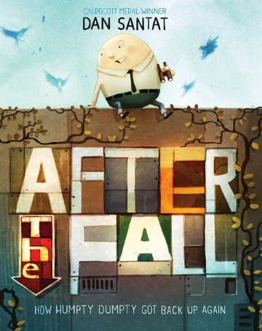  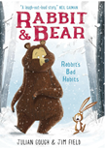 | 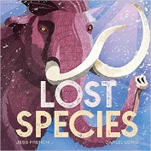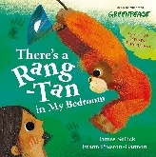 | 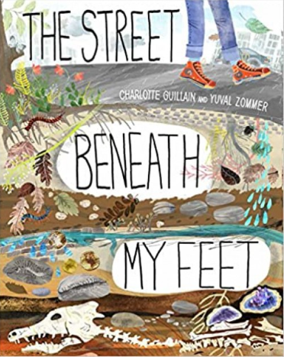  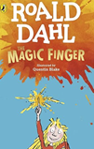 | 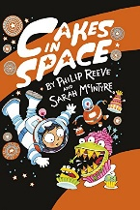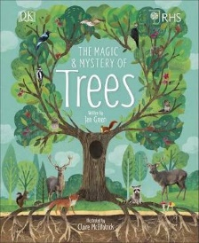 |  |  | 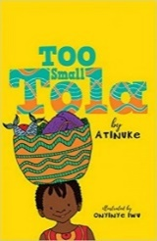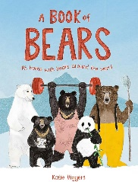 | 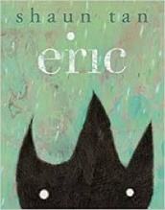  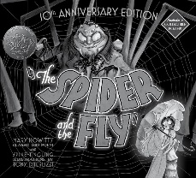
Maths | Please see the medium-term plan.
Science | Habitats |  | Animals inc. humans | Making new plants |  |  | Changing materials |  | Pushes & pulls
History/ Geography | Where are we in the world?  (Continents and oceans)  Geography | Nursing has not changed in over 100 years. True or false?  History | Let’s go on an adventure!  (maps)  Geography | Where do our school names come from?  History |  |  | The only way to fly is on a plane. True or false?  History | What is it like in other places?  (Aldershot vs Nepal)  Geography
PSHE | Me and My Relationships | Valuing Difference | Keeping Safe | My Rights and Respect |  | Being my Best |  | Growing and Changing
Art | Vincent Van Gogh (sunflowers).  Drawing | Layne Peters (clay)  Sculpture | Anne Kelly  Collage/textiles |  |  | Francis Bowyer (backgrounds)  Painting
Design and Technology | Cooking & Nutrition – Healthy Wraps  Linked to Continents & Oceans – where food comes from |  | Sewing – Mixed media sewing collage (linked to Art)  Linked to History of Aldershot |  |  | Construction – 3D model aeroplane with wheels & axels  Linked to Aeroplanes/Aviation
Religious Education | Special place (Mandir)  Hinduism | Waiting (Advent)  Christianity | Remembering (Holi)  Hinduism | Love as sad and happy (The Easter story)  Christianity |  | Special food  Across religion and traditions |  | God  Christianity and Hinduism
Computing | Online safety | Creating media – Digital photography | Programming A – Robot algorithms | Data collection - Pictograms |  | Creating media – Digital music |  | Programming B – Programming quizzes
Physical Education | Run, Jump, Throw 1  Gymnastics 1 | Run, Jump, Throw 1  Gymnastic 2 | Send & Return (1)  Hit, Catch, Run 1 | Send & Return (2)  Hit, Catch, Run 2 |  | Dance (Specialist)  Attack, Defend, Shoot 1 |  | Dance  Attack, Defend, Shoot 2
Music | “Dragons”  Dynamics (getting louder or quieter).  Tempo (getting faster or slower). | “Christmas is Coming”  Pitch (higher, lower sounds, steps, leaps and repeated notes).  Duration (Steady beat and rhythm patterns). | “Jolly Rogers”  Structure (verse and chorus)  Timbre (how are sounds made?) | “Wispy Willow”  Pitch (higher, lower sounds shape of melodies) |  | “Man on the Moon”  Timbre (choose how to make sounds to suit mood)  Texture (layer sounds) |  | “Minibeasts On the Move”  Duration (steady beats and rhythm patterns)
Trips/Themed Days | Fort Nelson |  | Chicks at school |  |  | Brooklands Museum

