 | Autumn 1 |  | Autumn 2 | Spring 1 |  | Spring 2 |  |  | Summer 1 | Summer 2
Topic | Feelings  Changes in living memory (toys)  Materials |  | Celebrations  Seasons | Space  Plants |  |  |  |  | PSHE – Being My Best  Animals Including humans  Habitats | Oceans and Seas
Main Text | 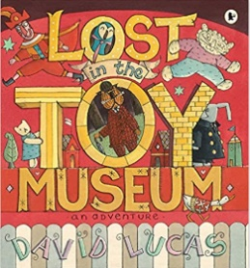  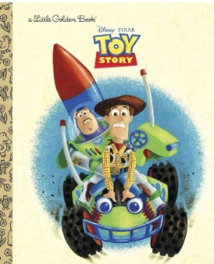  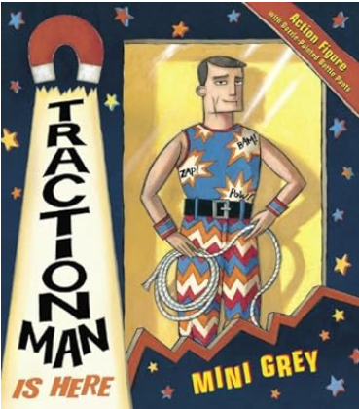 |  | 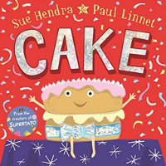  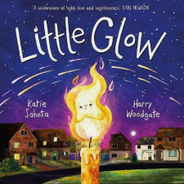  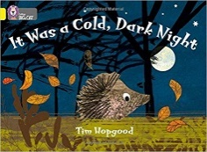 | 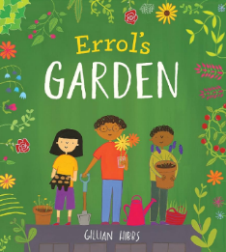  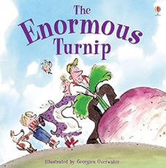  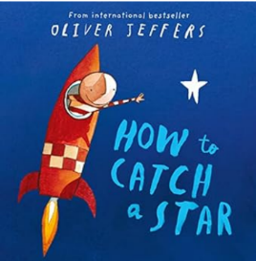 |  | 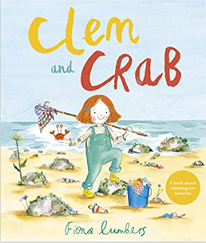  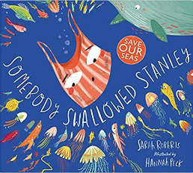 |  |  | 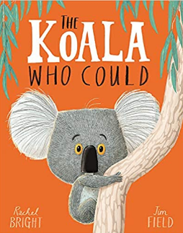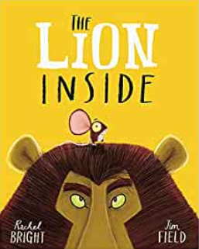 | 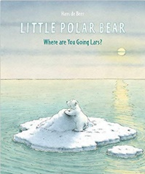  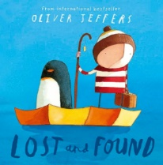
Writing Outcomes from entire unit | Toy Story  Outcome: To write a label  Purpose: inform  Audience:  Form: information text  Lost in the Toy Museum  Outcome: Description  Purpose: entertain  Audience:  Form: Narrative  Traction Man  Outcome:  Purpose:  Audience:  Form: Narrative |  | It was a cold dark night  Outcome: Facts/ Animal riddle  Purpose: inform  Audience:  Form: Sentences  Cake  Outcome: To write a description of the cake  Purpose: entertain  Audience:  Form: description  Little Glow  Outcome: To write a party invitation  Purpose: inform  Audience:  Form: Narrative  Outcome: To write a recipe on how to be a good friend  Purpose: inform  Audience:  Form: instructions | How to Catch a Star  Outcome: simple retelling of the beginning of the story  Purpose: entertain  Audience:  Form: narrative  Erol’s Garden/Enormous Turnip.  Outcome: To write a non-chronological report  Purpose: inform  Audience:  Form: information text | Clem and Crab  Outcome: To create a poster (instruction on how to recycle)  Purpose: inform  Audience: wider school  Form: instructions  Somebody Swallowed Stanley  Outcome: Character Description/Rhyming  Purpose: entertain  Audience:  Form: Description  A Great Big Cuddle Outcome: Poem  Purpose: entertain  Audience:  Form: Poem |  |  |  | Lion Inside  Outcome: To write a character profile- description of the mouse and the lion  Purpose: entertain  Audience:  Form: description  The Koala who could: Recipe for a good friend  Purpose: inform  Audience:  Form: instructions | Lost and Found  Outcome: simple story sequence  Purpose: entertain  Audience: reader  Form: narrative  Little Polar bear  Outcome: To write a non-chronological report  Purpose: inform  Audience:  Form: information text  Outcome: fact file on polar bears/ arctic animals.  Purpose: inform  Audience:  Form: information text
Maths | Please see the medium-term plan.
Science | Describing materials  How can we describe materials? | Seasons  Do seasons affect habitats? |  | Habitats  What is a habitat? |  | Plants  How do plants grow? |  |  | Animals including Humans  How do animals survive?
History/ Geography | How have toys changed over time?  History |  | What is our local area like?  Geography | Who was the first person to space?  History |  | Where is our ‘local’ area? (maps)  Geography |  |  | Who was to blame for the Great Fire of London?  History | Where are we in the UK? (4 countries and capitals of UK)  Geography
PSHE | Happy Relationships  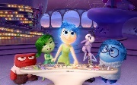  Big Think: Do you think some emotions are better than others? |  | We are all Different  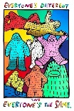  Big Think: What does the artist mean when he says everyone is the same and everyone is different? | Keeping Safe    Big Think: Being safe means crossing the road safely. True or false? |  | My Rights and Respect  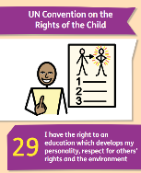  Big Think: My rights are more important than anyone else’s. True or false? |  |  | Being my Best  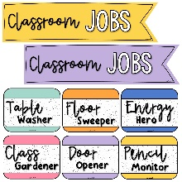  Big Think: What can I aspire to do and be? | Growing and Changing  Big Think:
Art |  |  | Painting:  Georges Seurat (pointillism)  Could link to Local Area unit | Printing:  Orla Kiely  Could link to Plants and/or explorers |  |  |  | Drawing:  Matisse  Could link to ‘Explorers’ | Sculpture:  Barbara Hepworth (Family of Man)
Design and Technology | Construction - Junk model with sliders and levers  Linked to Toys through Time |  |  |  |  |  | Sewing – Puppets  Linked to Plants and Habitats  (Own astronaut) |  |  | Cooking & Nutrition – Fruit Salads Linked to Nature & Explorers
Religious Education | Thanking  Christianity |  | Journey’s end  Christianity  The nativity journey | Belonging (Golden Thread)  Christianity |  | Welcoming  Christianity  Palm Sunday |  |  | Community (Golden Thread)  Hinduism | Story  Across religions
Computing | Programming – Making a robot move |  |  | Online safety |  |  |  | Creating media – Digital writing | Creating media – Digital painting | Creating media – Talking books
Additional  computing | Online safety 1 lesson per half term (Use previous unit but break up)
Physical Education | Run, Jump, Throw 1  Gymnastics 1 |  | Run, Jump, Throw 2  Gymnastics 2 | Send & Return 2  Hit, Catch, Run 1 |  | Send & Return 2  Hit, Catch, Run 2 |  |  | Dance (Teacher led)  Attack, Defend, Shoot 1 | Dance (Specialist)  Attack, Defend, Shoot 2
Music | “Toys”  Dynamics (loud, quiet, silence)  Tempo (fast, moderate and slow) |  | “Can I Be Helpful Too?”  Duration (steady beat, rhythms)  imbre (the quality of the sound). | “As Cold As Ice”  Duration (long and short sounds, steady beat), Structure (beginning, middle end) |  | “The Old Castle”  Timbre (the quality of the sound). |  |  | “Walking the Dog”  Duration (long and short sounds) and Structure (patterns in sound). | “The Three Bears”  Pitch (high, middle, low sounds).
Trips/Themed Days | Milestones  October 10th |  |  | Wisley Gardens  March 27th |  |  |  |  | Marwell Zoo  May 22nd

